Task - 1

**Create a Lightning Web Component that will be immediately useful for RecordPage, HomePage, and AppPage.**

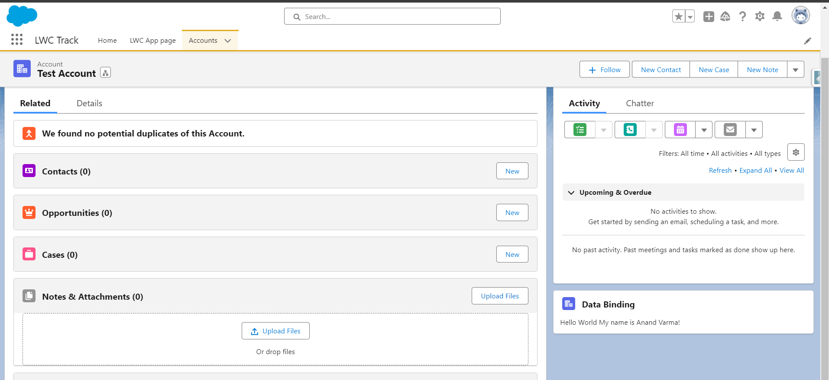

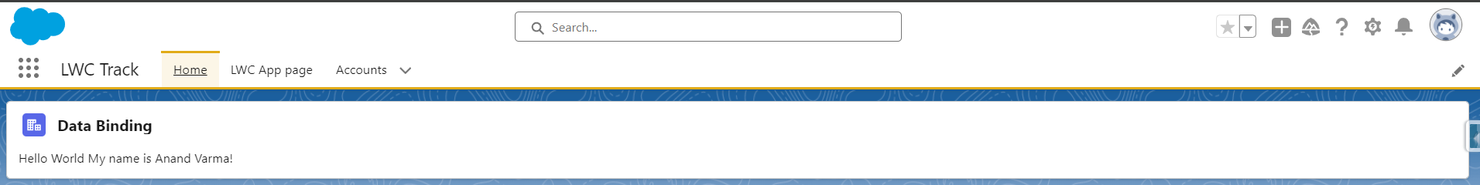

**Task 2**

**Challenge yourself by writing a text inside the “Hello World ! My Name is <YOUR_NAME>” component. Use the lightning card inside the element and data binding concept to show your name.**

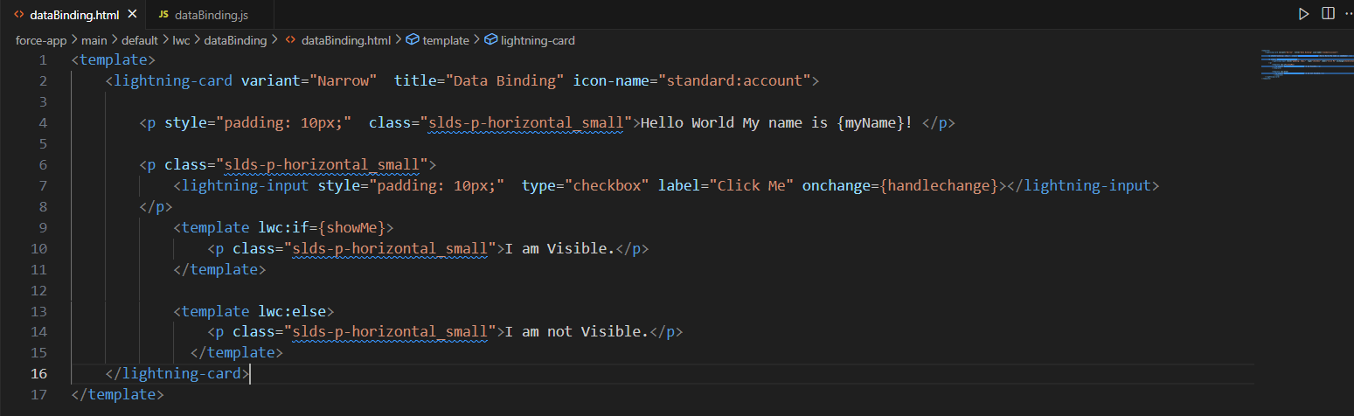

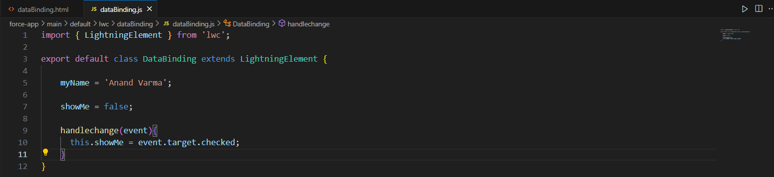

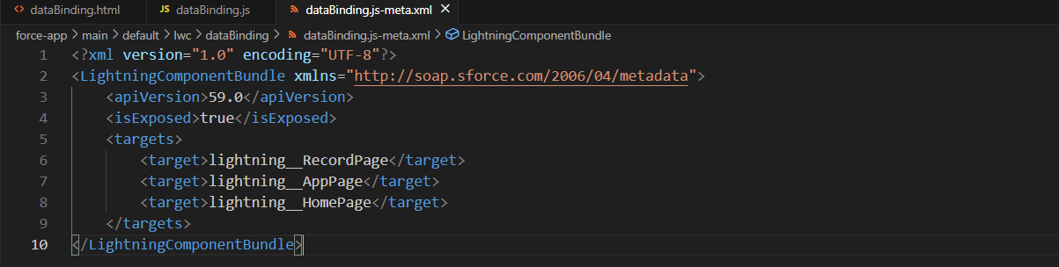

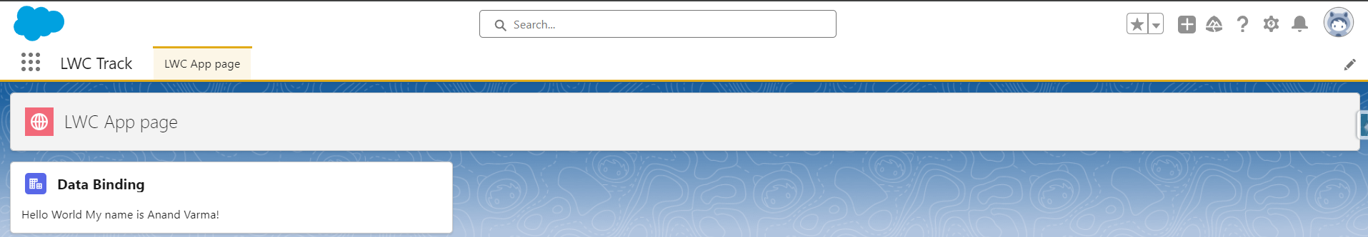

**Task 3**

**Make a lightning check box inside the component to only show this text on actual value. (Conditional Rendering)**

